**Project Design Phase-II**

**Technology Stack (Architecture & Stack)**

|  |  |
| --- | --- |
| **Team ID** | **PNT2022TMID20252** |
| **Project Name** | **IoT based smart crop protection system for Agriculture** |
| **Maximum Marks** | **4 Marks** |

**TECHNICAL ARCHITECTURE:**

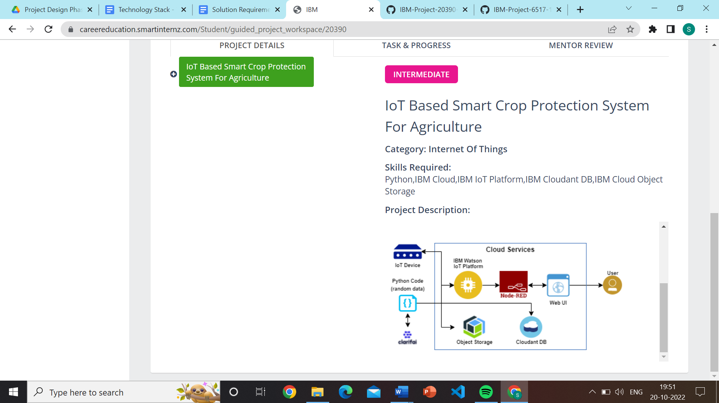

**TABLE-1: COMPONENTS & TECHNOLOGIES:**

|  |  |  |  |
| --- | --- | --- | --- |
| **S.No** | Component | Description | Technology |
| 1. | User Interface | How user interacts with the Mobile and Web Application | App and web development |
| 2. | Application Logic-1 | Logic for a process in the application | Python Objectives |
| 3. | Application Logic-2 | Logic for a process in the application | IBM Watson STT service |
| 4. | Application Logic-3 | Logic for a process in the application | Node-RED service |
| 5. | Database | Data Type | MySQL |
| 6. | Cloud Database | Database Service on Cloud | Cloudant DB |
| 7. | File Storage | File storage requirements | IBM Block Storage |
| 8. | Infrastructure (Server / Cloud) | Application Deployment on Local System / Cloud Local Server Configuration  Cloud Server Configuration | Cloud Foundry |
| 9. | External API-1 | Purpose of external API used in the application | IBM weather API etc., |
| 10. | IOT Model | Purpose of IOT Model for integrating the sensors with the user interface. | IBM IOT platform. |

**TABLE-2: APPLICATION CHARACTERISTICS:**

|  |  |  |  |
| --- | --- | --- | --- |
| **S.No** | **Characteristics** | **Description** | **Technology** |
| 1. | Open-source Frameworks | The open-source frameworks used | SAN-SAF |
| 2. | Security Implementations | List all the security / access controls implemented | IBM cloud encryptions |
| 3. | Scalable Architecture | Justify the scalability of architecture (3 – tier,  Micro-services) | IBM cloud Architecture |
| 4. | Availability | Justify the availability of applications (e.g. use of load balancers, distributed servers etc.) | Application can be used by the farmers anywhere, anytime. |
| 5. | Performance | Design consideration for the performance of the application | It can be used by the farmers 24x7 and highly reliable |